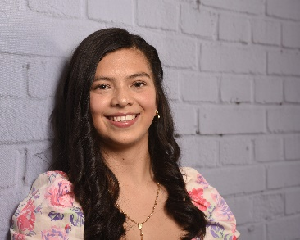
Valerie Sanchez Caro
Award: $3,000
High School Youth- Madison High School
School: Undecided
Major: Business

Valerie Sanchez Caro is currently a senior at Madison High School and a first-time recipient of the NJNAHRO Scholarship. She is interested in attending Fairleigh Dickinson University, Seton Hall University, College of St. Elizabeth, Caldwell University, or Kean University. Valerie immigrated to the United States with her parents from Colombia, ten years ago. They immigrated in order to have a better life with more opportunities to achieve their dreams. Valerie wants to go to college because it is the step to achieving her American Dream. She is interested in studying business because she wants to pursue her dream of starting her own business one day. A college degree will give her a lot of opportunities to succeed.
Father Yojaneider Garcia, of the Diocese of Paterson, stated that Valerie is honest, trustworthy, and intelligent. He also stated that she is a person of integrity and very loved in the parish community. Her employer at New Leaf Consignment, Stephanie Vezza, described Valerie as a hard-working and dedicated employee who is always eager to learn.

Areeba Siddiq is currently a senior in Secaucus High School and a first-time recipient of the NJNAHRO Scholarship. She is planning on attending Penn State Altoona in the fall to study law. Areeba became interested in law after seeing her cousin be wrongly convicted and incarcerated at a young age. She spent a lot of time in courtrooms and realized that, since they could not afford a good lawyer, her cousin was not being represented as well as he could be. It was then that she realized that she wanted to become a lawyer, to help those who could not afford a lawyer. She wants to help repair the broken justice system.
Areeba Siddiq
Award: $3,000
High School Youth- Dover High School
School: Massachusetts College of Pharmacy and Health Sciences
Major: Pharmacology
Areeba’s guidance counselor, Cate Suzano, described her as an intelligent and driven student who sees the good in everyone. She believes that Areeba has a great potential to succeed and hopes she excels in her mission of helping others. Her Social Studies teacher, Gregory Lekakis, described Miss Siddiq as a conscientious and devoted student who is very active in her community, partaking in multiple extracurricular activities.
Betsabe Paulino
Award: $2,500
High School Youth- Secaucus High School
School: Fairleigh Dickinson University
Major: Forensic Psychology

Betsabe Paulino is currently a senior in Secaucus High School and a first-time NJNAHRO Scholarship recipient. She plans on attending Fairleigh Dickinson University in the fall to study Forensic Psychology. She has been interested in psychology ever since she was a young girl because she was always intrigued about how people behaved and why they did so. Betsabe wants to study Forensic Psychology because she is interested in the logistics of investigating crime scenes, as well as the study of the human mind. She will complete a 5 year accelerated master’s program in which she will earn a bachelor’s and master’s degree. These two degrees will give her more opportunities to pursue her dream career.
Her guidance counselor, Tara Tavares, stated that she is a highly motivated, energetic, and compassionate young lady. Her compassionate nature shines through with the extensive community service she does. She has participated in various events, such as Senior Citizen Prom, a walk-a-thon, and many other events. Megan Miller, her Social Studies teacher, describes her as diligent, hard-working, and disciplined.

Alicia Ciprian
Award: $2,500
Continuing Education- Rutgers University
School: Rutgers University
Major: Environmental Policy, Institutions, and Behavior

Alicia Ciprian is currently a junior at Rutgers University and a first-time recipient of the NJNAHRO Scholarship. She is currently pursuing a bachelor’s degree in Environmental Policy, Institutions, and Behavior with a minor in Geography. She has always known that she wanted to major in something related to Environmental Science and settled on Environmental Policy. She decided to minor in Geography after she took a couple of Geography classes that intrigued her. Miss Ciprian hopes that with her degree she can inflict positive change in the environment.
According to her professor, Nancy Glazer, Miss Ciprian is a serious and dedicated student who had perfect attendance in her class. Miss Ciprian has been described to be a valuable asset in both her internship and work study positions. Her supervisor in her work study position, Alexandra Cross, stated that Miss Ciprian was a diligent and attentive worker who always tries to go above and beyond. Her internship supervisor, Thomas Lott, stated that she is an efficient and enthusiastic worker.

Ashley Montoya is currently a senior in Dover High School and a first-time recipient of the NJNAHRO Scholarship. She will be attending the Massachusetts College of Pharmacy and Health Sciences in the fall to study pharmacology. Her mother wanted her to go into the medical field, however, Ashley was not sure what she wanted to study in college at first until she started to work in the pharmacy at CVS. She was warned that working in the pharmacy was difficult and demanding. However, she ended up enjoying working there, and she made the decision to study pharmacology. Before she did not believe she could study medicine, but her job at CVS was the push she needed to find her passion and the confidence she needed to pursue pharmacology.
Ashley Montoya
Award: $2,000
High School Youth- Dover High School
School: Massachusetts College of Pharmacy and Health Sciences
Major: Pharmacology
Her Youth Pastor, Jessica Diaz, discussed her volunteer work with her church, which has spanned seven years. She also described her as an enthusiastic, helpful person who is always offering a helping hand. Her English Teacher, Dawn Sperry, stated that she is resourceful, adaptable, and responsible.

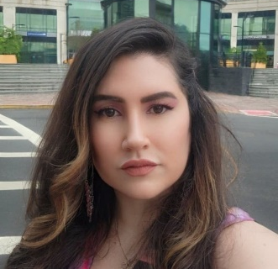
Michelle Gavilanes
Award: $2,000
Continuing Education- Kean University
School: Kean University
Major: Recreation Therapy/Community Recreation

Michelle Gavilanes is currently a student at Kean University and first time recipient of the NJNAHRO Scholarship. She is a Recreation Therapy/Community Recreation major. Ms. Gavilanes became interested in Recreational Therapy when she suffered a traumatic brain injury in 2005. Her traumatic brain injury resulted in many complications, such as depression, anxiety, and neuropathic pain. Her time at recreational therapy gave her the hope and support she needed at the time. She wants to help and advocate for people with mental disabilities because she believes that it is a serious issue that needs to be addressed with more urgency and resources. She is minoring in Public Health to be able to advocate and allocate more funding for mental health organizations and agencies in New Jersey.
Michelle’s Program Planning Professor, Anthony Traverso, described her as hardworking, dedicated, and perseverant. Another one of her professors, Dr. Fran Stavola Daly, stated that she has a genuine and welcoming personality and is always willing to help other. They also admired the fact that she has been able to maintain a 4.0 GPA despite the many challenges she faces.

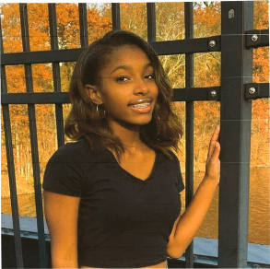
Layla Coache
Award: $2,000
Continuing Education- Montclair State University
School: Montclair State University
Major: Educational Foundations

Layla Coache, from the Boonton Housing Authority, is currently a student at Montclair State University and a first-time recipient of the NJNAHRO Scholarship. She is majoring in Educational Foundations. She has been interested in teaching since she was young. Her passion has always been to teach, inspire, and motivate others. Growing up she was constantly doing this, since she is the oldest of her siblings. Since she began to study at Montclair State, her interest in pursuing education has only grown. She plans to become a teacher to achieve her goal of teaching and inspiring others as well as to help young kids in her community.
Makeba Barnes, Layla’s mentor during her junior and senior year, stated that Layla demonstrated strong leadership and communication skills, as well as being generous and tech savvy. Kenneth Kelshall, an FSS Coordinator from the Boonton Housing Authority, described her as an ambitious, caring, and a dedicated person.

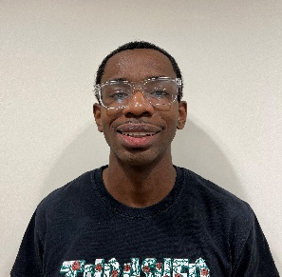
Raequan Houston
Award: $2,000
Continuing Education- County College of Morris
School: County College of Morris
Major: Music

Raequan Houston is currently a music student at the County College of Morris and a first time recipient of the NJNAHRO Scholarship. Music plays a major role in Raequan’s life. Both listening to music and making music serve as coping mechanisms for him. Attending CCM has been a great learning experience for him and his journey as a musician. He has learned about music production, discovered new music genres, and explored different mediums of music, such as choir.
Lisa Jorgensen, an FSS Service Coordinator, discussed the great tenacity that Raequan has. He is so determined and devoted to his education that he takes public transportation or walks to class, which can make the commute even longer sometimes being up to 2 hours. Despite this obstacle, he remains positive and eager to learn. His History Professor, Alexander Clemente, stated that he is a respectful, humble, and polite person.

Nelson Montoya
Award: $1,500
Continuing Education- Universal Technical Institute
School: Universal Technical Institute
Major: Automotive Technology

Nelson Montoya is currently a student at Universal Technical Institute and a first-time recipient of the NJNAHRO Scholarship. He is currently studying Automotive Technology. At first, Nelson did not have any idea what he wanted to do after graduation. He thought that attending college was the only way one can have a successful career, however that did not seem appealing to him. He had always had a love for cars ever since he was young, so he decided to go to Universal Technical Institute to study to become a mechanic.
Earl Thomas, a fellow volunteer, stated that Nelson is a hard worker, kind, and compassionate. Gilbert Behr, his manager at Stowaway Self Storage, described him as a determined, motivated, and committed young man with strong communication skills.

Bryan Reyes
Award: $1,500
High School Youth- Union City High School
School: Undecided
Major: Undecided

Bryan Reyes is currently a senior at Union City High School and a first-time recipient of the NJNAHRO Scholarship. He plans on attending either Hudson Community College or New Jersey City University in the fall. When Bryan was 11, he moved to the United States, leaving most of his family behind for a better life. His grandparents have always wanted him to be the first in his family to attend and graduate college. Over time, he started to follow the wrong crowd and lose sight of that goal. However, during his freshman year of high school, his girlfriend got pregnant with his son, so he knew he had to get his act together. Bryan wants to attend college to help support his family in the future.
His ESL Teacher, Nadia Musbeh, remarked about his perseverance in adversity and hardworking nature. She talked about the progress he made throughout the school year and how he did not let his setbacks come in the way of his education. His Medical Assistant and Healthcare Teacher, Armando Ovalles, described Bryan as polite, level-headed, and responsible.

Judith Amenowode
Award: $1,500
Continuing Education- New Jersey City University
School: New Jersey City University
Major: Nursing

Judith Amenowode is currently a nursing student at New Jersey City University and a first-time recipient of the NJNAHRO Scholarship. Judith has dreamed of being a nurse since she was a child. She is drawn to nursing because of the rigorous training that will challenge her as well as being able to help others. Her desire to become a nurse became greater when she was hit by a car as a teenager and remained in a coma for five days. She will never forget how well the nurses took care of her. She wants to be able to do the same thing her nurses did for her back then.
Dr. Karl C. Alorbi, an acquaintance of Judith’s, described her as a hardworking and selfless person who is passionate about helping others. Her English Professor at County College of Morris, Kevin Moore, stated that she was always determined to learn the material of the class and asked questions about the material. He also stated that she is a kind and gracious person.

Lilyanette Jimenez Vega
Award: $1,500
High School Youth- Passaic Valley Regional High School
School: Fairleigh Dickinson University
Major: Undecided

Lilyanette Jimenez Vega is currently a senior at Passaic Valley Regional High School and a first-time recipient of the NJNAHRO Scholarship. She plans to attend Fairleigh Dickinson University in the fall. Lilyanette has gone through her fair share of hardships throughout her life, the most impactful being the death of her grandfather. Her grandfather was like the father she never had, so losing him was devastating to her. However, she has since begun to heal and is ready to graduate and attend college with her head held up high.
Her school counselor, Jennifer Shue, described Lilyanette as a hardworking and intelligent student with a kind soul. She also discussed how Lilyanette was able to put on a brave face when her grandfather died, despite how hard it was for her. Jeffrey Francisco, her Social Studies Teacher, stated that she is a courteous, focused, and diligent student.

